Тема 7: Векторный редактор.
Цель работы: получить практические навыки разработки иерархии классов сложных проектов, получить опыт применения команд графики и работы с бинарными файлами объектов данных для сохранения и загрузки построенных векторных изображений.

Основные классы проекта
- Разработать базовый класс «Фигура», позволяющий прорисовывать некую фигуру в заданной прямоугольной области, сдвигать фигуру по горизонтали и вертикали на 1 и на 5 пикселов, перемещать фигуру в заданную точку;
- Разработать производные классы фигур по индивидуальному заданию, все фигуры строятся относительно базовой точки (верхнего левого угла прямоугольной области);
- Разработать класс для контура фигуры (основные данные: толщина контура и его цвет);
- Разработать класс для сохранения последних изменений полотна;
- Разработать класс обрамления фигуры при её выделении (прорисовки маркеров по краям прямоугольной области фигуры).
Проект должен быть спроектирован таким образом, чтобы можно было легко наращивать его функционал, добавляя новые фигуры и инструменты, и при этом не пришлось бы заново переписывать весь код или копировать в несколько модулей одинаковые куски кода. Таким образом, надо создать демоверсию векторного редактора, в которой не очень много возможностей, но правильно заложены основы для развития проекта.
Вариант 6
Набор фигур: Квадрат, прямоугольник, Г-образная фигура, П-образная фигура
Дополнительные функции: Отражение и поворот фигуры
Схемы программы:
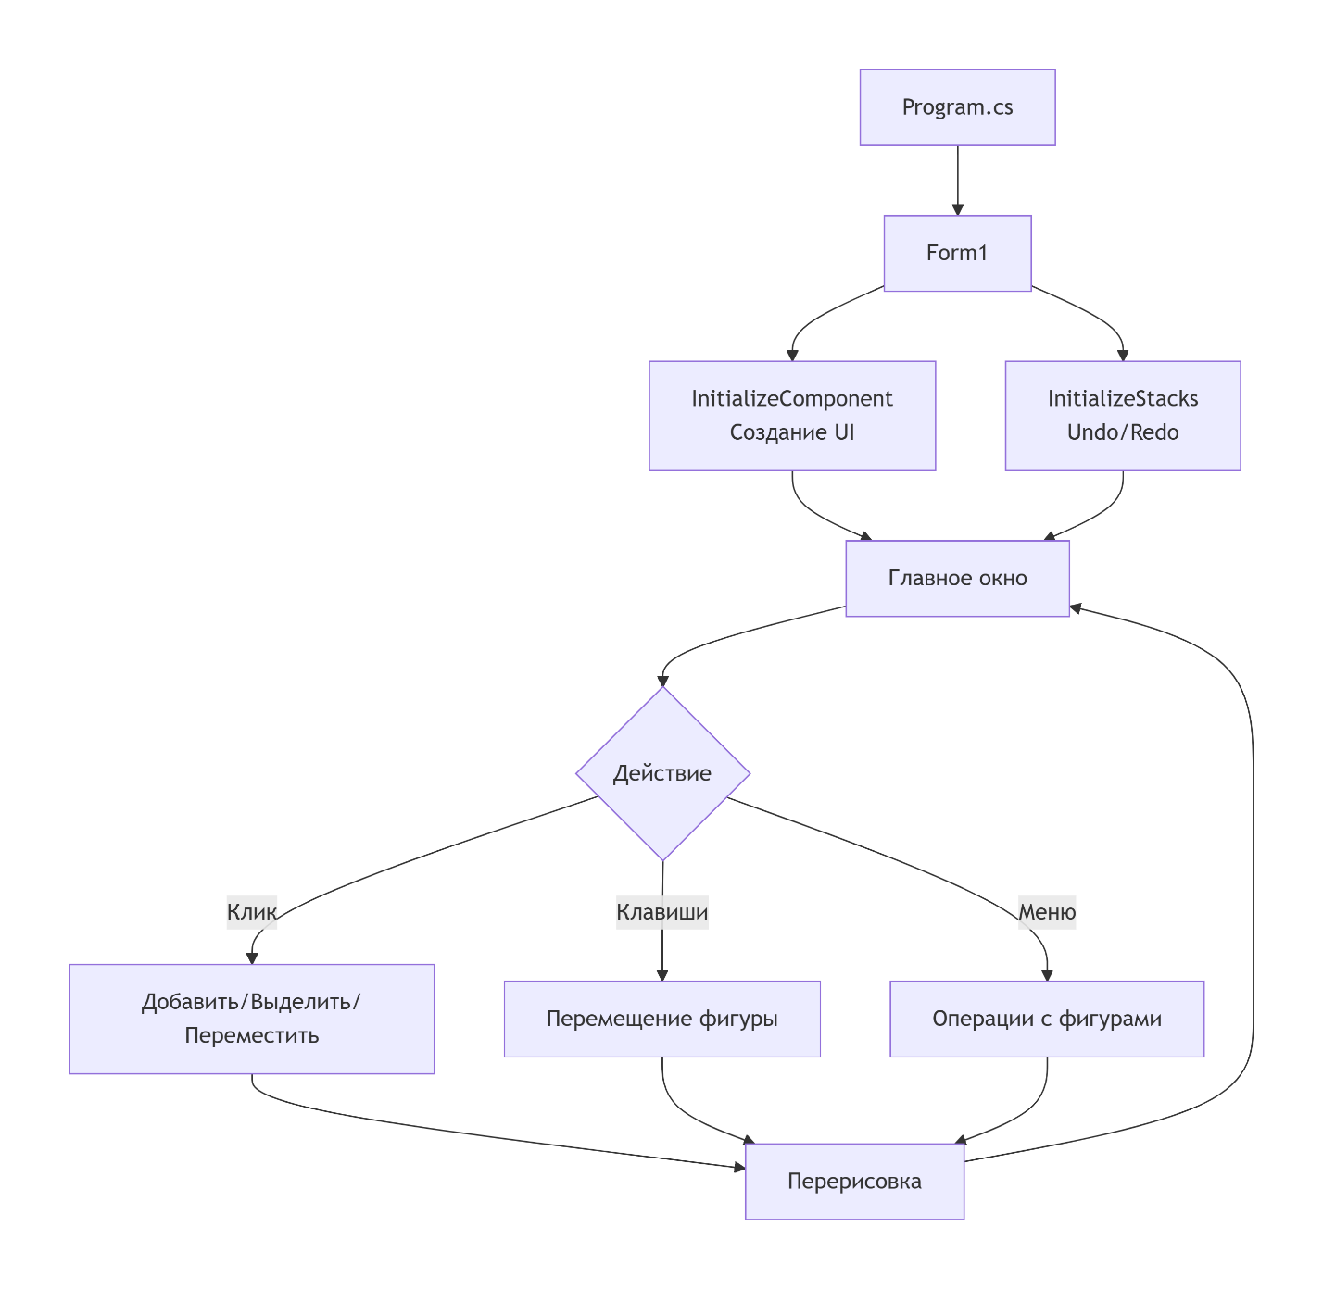

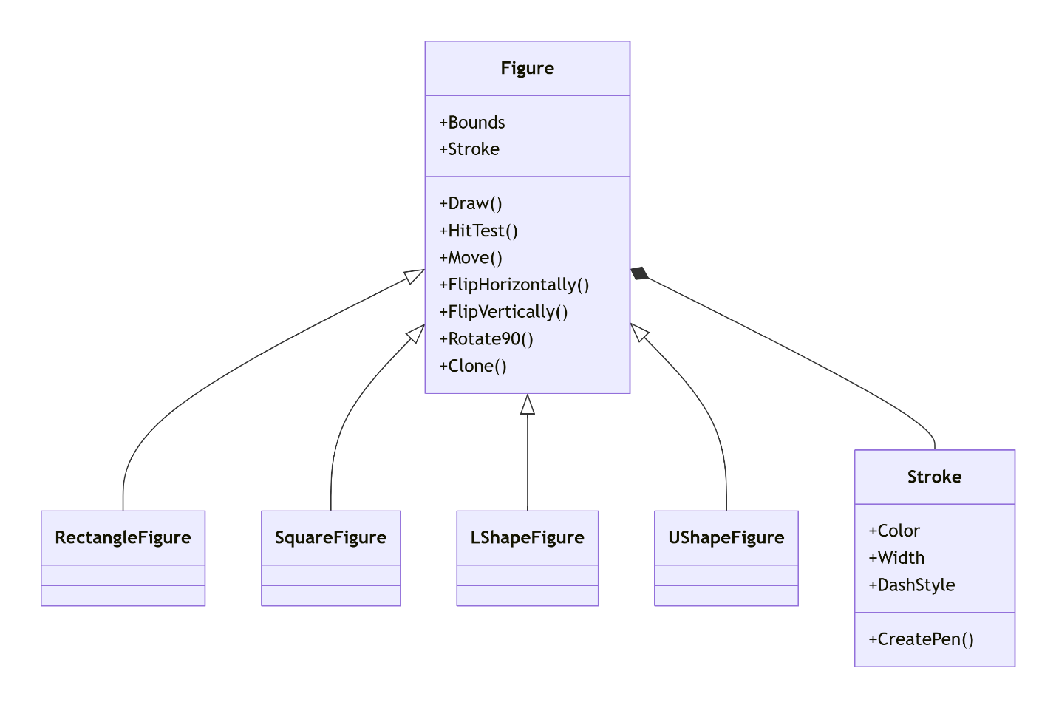
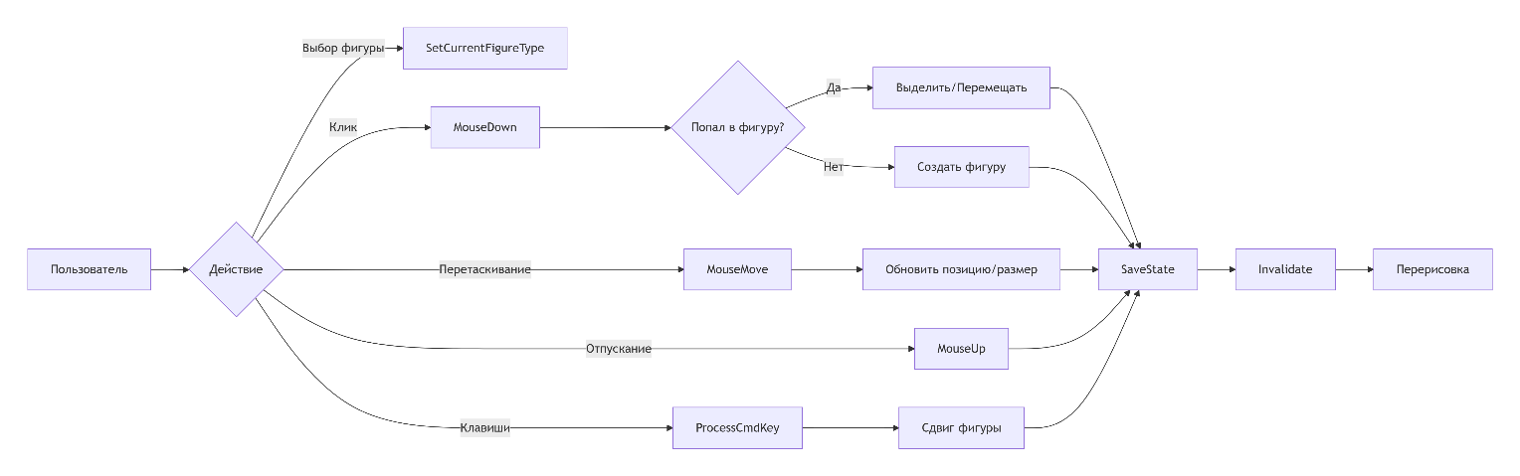
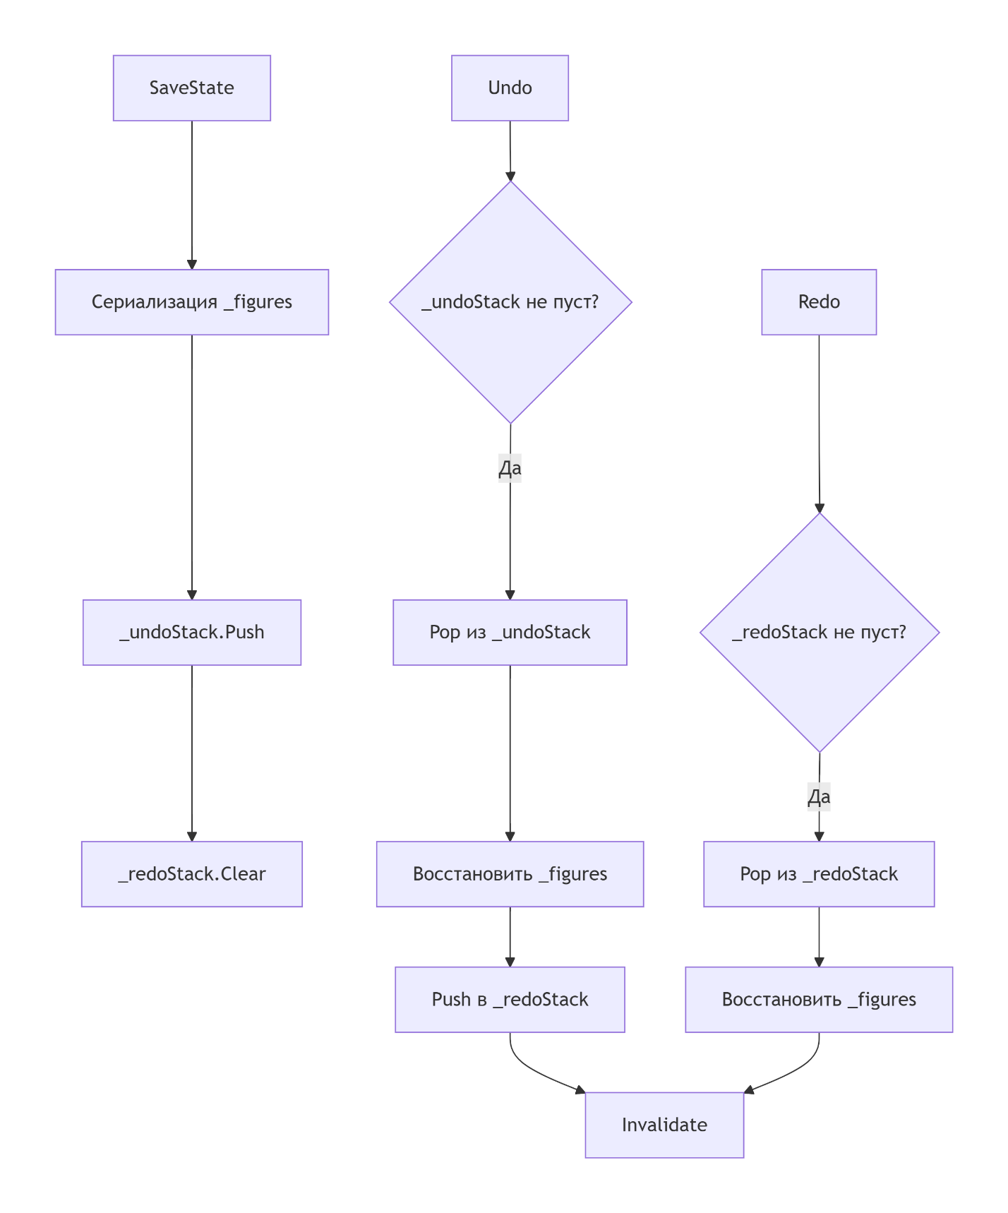
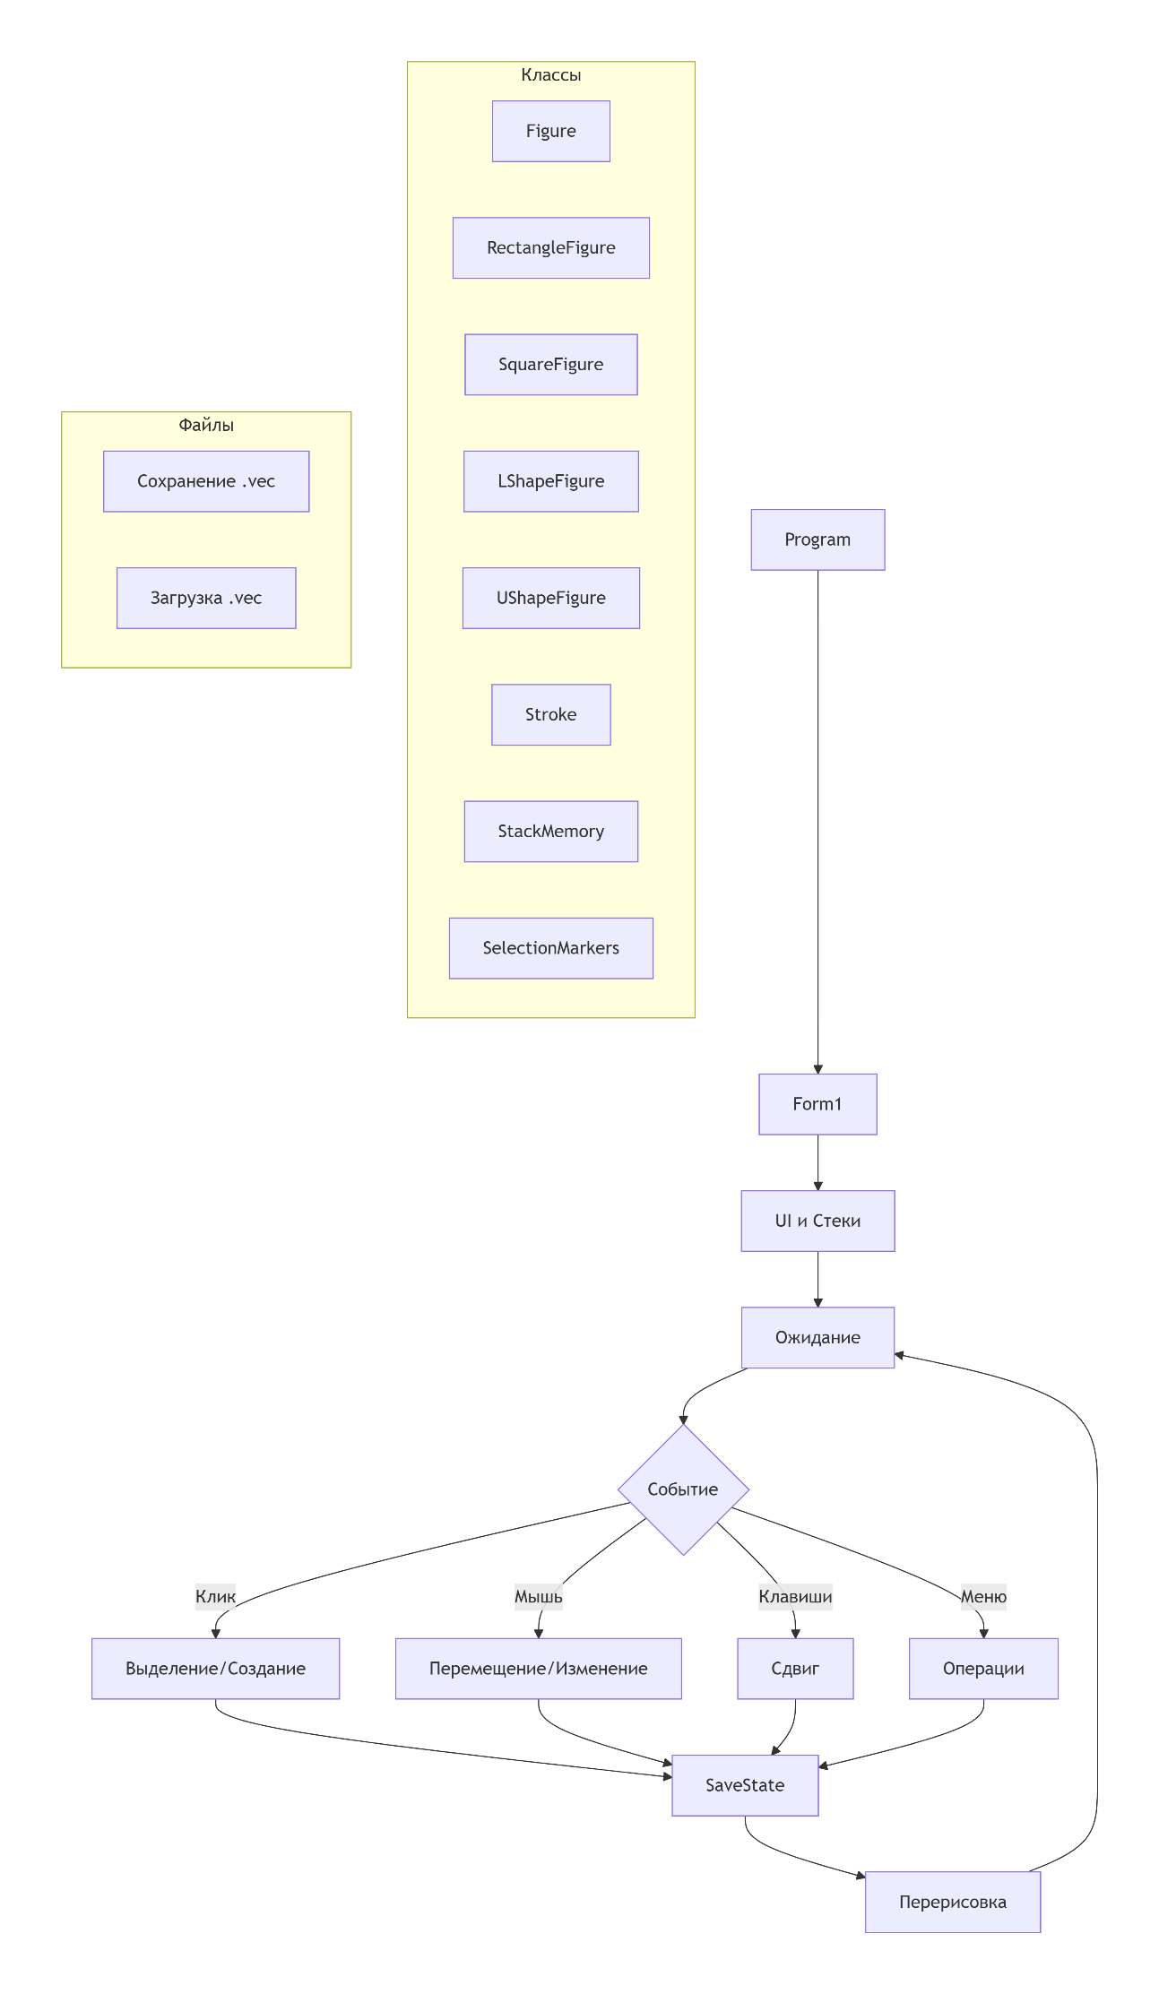
Figure.cs
using System;
using System.Drawing;
using VectorEditor.Utils;

namespace VectorEditor.Figures
{
/// <summary>
/// Базовый абстрактный класс для всех фигур
/// </summary>
[Serializable]
public abstract class Figure
{
/// <summary>
/// Прямоугольная область фигуры (верхний левый угол, ширина, высота)
/// </summary>
public Rectangle Bounds { get; set; }

/// <summary>
/// Контур фигуры
/// </summary>
public Stroke Stroke { get; set; }

/// <summary>
/// Конструктор
/// </summary>
protected Figure()
{
Stroke = new Stroke();
Bounds = new Rectangle(100, 100, 100, 100);
}

/// <summary>
/// Конструктор с параметрами
/// </summary>
protected Figure(Rectangle bounds, Stroke stroke)
{
Bounds = bounds;
Stroke = stroke ?? new Stroke();
}

/// <summary>
/// Отрисовка фигуры
/// </summary>
public abstract void Draw(Graphics g);

/// <summary>
/// Проверка попадания точки в фигуру
/// </summary>
public abstract bool HitTest(Point point);

/// <summary>
/// Сдвиг фигуры
/// </summary>
public virtual void Move(int dx, int dy)
{
Bounds = new Rectangle(Bounds.X + dx, Bounds.Y + dy, Bounds.Width, Bounds.Height);
}

/// <summary>
/// Перемещение в точку
/// </summary>
public virtual void MoveTo(Point newLocation)
{
Bounds = new Rectangle(newLocation.X, newLocation.Y, Bounds.Width, Bounds.Height);
}

/// <summary>
/// Изменение размера
/// </summary>
public virtual void Resize(int width, int height)
{
Bounds = new Rectangle(Bounds.X, Bounds.Y, width, height);
}

/// <summary>
/// Отразить по горизонтали
/// </summary>
public abstract void FlipHorizontally();

/// <summary>
/// Отразить по вертикали
/// </summary>
public abstract void FlipVertically();

/// <summary>
/// Повернуть на 90 градусов
/// </summary>
public abstract void Rotate90();

/// <summary>
/// Создать копию фигуры
/// </summary>
public abstract Figure Clone();

/// <summary>
/// Получить центр фигуры
/// </summary>
public virtual Point GetCenter()
{
return new Point(Bounds.X + Bounds.Width / 2, Bounds.Y + Bounds.Height / 2);
}
}
}

LShapeFigure.cs
using System;
using System.Drawing;
using System.Drawing.Drawing2D;
using VectorEditor.Utils;

namespace VectorEditor.Figures
{
/// <summary>
/// Г-образная фигура (состоит из двух прямоугольников)
/// </summary>
[Serializable]
public class LShapeFigure : Figure
{
// Для сериализации храним параметры частей
private Rectangle _part1;
private Rectangle _part2;

public LShapeFigure() : base()
{
InitializeParts();
}

public LShapeFigure(Rectangle bounds, Stroke stroke) : base(bounds, stroke)
{
InitializeParts();
}

private void InitializeParts()
{
int width = Bounds.Width;
int height = Bounds.Height;
int partWidth = width / 2;
int partHeight = height / 2;

// Вертикальная часть (левая)
_part1 = new Rectangle(Bounds.X, Bounds.Y, partWidth, height);
// Горизонтальная часть (нижняя)
_part2 = new Rectangle(Bounds.X + partWidth, Bounds.Y + partHeight, partWidth, partHeight);
}

private void UpdateParts()
{
int width = Bounds.Width;
int height = Bounds.Height;
int partWidth = width / 2;
int partHeight = height / 2;

_part1 = new Rectangle(Bounds.X, Bounds.Y, partWidth, height);
_part2 = new Rectangle(Bounds.X + partWidth, Bounds.Y + partHeight, partWidth, partHeight);
}

public override void Draw(Graphics g)
{
UpdateParts();
using (Pen pen = Stroke.CreatePen())
{
g.DrawRectangle(pen, _part1);
g.DrawRectangle(pen, _part2);
}
}

public override bool HitTest(Point point)
{
UpdateParts();
// Проверяем попадание в любую из частей
Rectangle expanded1 = new Rectangle(
_part1.X - (int)Stroke.Width,
_part1.Y - (int)Stroke.Width,
_part1.Width + (int)Stroke.Width * 2,
_part1.Height + (int)Stroke.Width * 2);

Rectangle expanded2 = new Rectangle(
_part2.X - (int)Stroke.Width,
_part2.Y - (int)Stroke.Width,
_part2.Width + (int)Stroke.Width * 2,
_part2.Height + (int)Stroke.Width * 2);

return expanded1.Contains(point) || expanded2.Contains(point);
}

public override void Move(int dx, int dy)
{
base.Move(dx, dy);
UpdateParts();
}

public override void MoveTo(Point newLocation)
{
base.MoveTo(newLocation);
UpdateParts();
}

public override void Resize(int width, int height)
{
base.Resize(width, height);
UpdateParts();
}

public override void FlipHorizontally()
{
// Отражение по горизонтали
int newX = Bounds.X;
int newY = Bounds.Y;
// Меняем структуру фигуры
int partWidth = Bounds.Width / 2;
int partHeight = Bounds.Height / 2;

_part1 = new Rectangle(newX + partWidth, newY, partWidth, Bounds.Height);
_part2 = new Rectangle(newX, newY + partHeight, partWidth, partHeight);

UpdateBoundsFromParts();
}

public override void FlipVertically()
{
// Отражение по вертикали
int newX = Bounds.X;
int newY = Bounds.Y;
int partWidth = Bounds.Width / 2;
int partHeight = Bounds.Height / 2;

_part1 = new Rectangle(newX, newY + partHeight, partWidth, partHeight);
_part2 = new Rectangle(newX + partWidth, newY, partWidth, Bounds.Height);

UpdateBoundsFromParts();
}

public override void Rotate90()
{
// Поворот на 90 градусов
int newWidth = Bounds.Height;
int newHeight = Bounds.Width;
int newX = Bounds.X + (Bounds.Width - newWidth) / 2;
int newY = Bounds.Y + (Bounds.Height - newHeight) / 2;

Bounds = new Rectangle(newX, newY, newWidth, newHeight);
UpdateParts();
}

private void UpdateBoundsFromParts()
{
int minX = Math.Min(_part1.X, _part2.X);
int minY = Math.Min(_part1.Y, _part2.Y);
int maxX = Math.Max(_part1.X + _part1.Width, _part2.X + _part2.Width);
int maxY = Math.Max(_part1.Y + _part1.Height, _part2.Y + _part2.Height);

Bounds = new Rectangle(minX, minY, maxX - minX, maxY - minY);
}

public override Figure Clone()
{
return new LShapeFigure(Bounds, Stroke);
}
}
}

RectangleFigure.cs
using System;
using System.Drawing;
using VectorEditor.Utils;

namespace VectorEditor.Figures
{
/// <summary>
/// Класс прямоугольника
/// </summary>
[Serializable]
public class RectangleFigure : Figure
{
public RectangleFigure() : base() { }

public RectangleFigure(Rectangle bounds, Stroke stroke) : base(bounds, stroke) { }

public override void Draw(Graphics g)
{
using (Pen pen = Stroke.CreatePen())
{
g.DrawRectangle(pen, Bounds);
}
}

public override bool HitTest(Point point)
{
// Проверка попадания в контур (с учётом толщины линии)
Rectangle expandedBounds = new Rectangle(
Bounds.X - (int)Stroke.Width,
Bounds.Y - (int)Stroke.Width,
Bounds.Width + (int)Stroke.Width * 2,
Bounds.Height + (int)Stroke.Width * 2);

return expandedBounds.Contains(point);
}

public override void FlipHorizontally()
{
// Для прямоугольника отражение не меняет форму
}

public override void FlipVertically()
{
// Для прямоугольника отражение не меняет форму
}

public override void Rotate90()
{
// Меняем ширину и высоту местами
Bounds = new Rectangle(Bounds.X, Bounds.Y, Bounds.Height, Bounds.Width);
}

public override Figure Clone()
{
return new RectangleFigure(Bounds, Stroke);
}
}
}

SquareFigure.cs
using System;
using System.Drawing;
using VectorEditor.Utils;

namespace VectorEditor.Figures
{
/// <summary>
/// Класс квадрата
/// </summary>
[Serializable]
public class SquareFigure : Figure
{
public SquareFigure() : base()
{
// Квадрат: ширина равна высоте
Bounds = new Rectangle(100, 100, 100, 100);
}

public SquareFigure(Rectangle bounds, Stroke stroke) : base(bounds, stroke)
{
// Приводим к квадрату
int size = Math.Min(bounds.Width, bounds.Height);
Bounds = new Rectangle(bounds.X, bounds.Y, size, size);
}

public override void Draw(Graphics g)
{
using (Pen pen = Stroke.CreatePen())
{
g.DrawRectangle(pen, Bounds);
}
}

public override bool HitTest(Point point)
{
Rectangle expandedBounds = new Rectangle(
Bounds.X - (int)Stroke.Width,
Bounds.Y - (int)Stroke.Width,
Bounds.Width + (int)Stroke.Width * 2,
Bounds.Height + (int)Stroke.Width * 2);

return expandedBounds.Contains(point);
}

public override void FlipHorizontally() { }

public override void FlipVertically() { }

public override void Rotate90()
{
// Квадрат не меняет форму при повороте
}

public override void Resize(int width, int height)
{
int size = Math.Min(width, height);
Bounds = new Rectangle(Bounds.X, Bounds.Y, size, size);
}

public override Figure Clone()
{
return new SquareFigure(Bounds, Stroke);
}
}
}

UShapeFigure.cs
using System;
using System.Drawing;
using System.Drawing.Drawing2D;
using VectorEditor.Utils;

namespace VectorEditor.Figures
{
/// <summary>
/// П-образная фигура (состоит из трёх прямоугольников)
/// </summary>
[Serializable]
public class UShapeFigure : Figure
{
private Rectangle _leftPart;
private Rectangle _rightPart;
private Rectangle _bottomPart;

public UShapeFigure() : base()
{
InitializeParts();
}

public UShapeFigure(Rectangle bounds, Stroke stroke) : base(bounds, stroke)
{
InitializeParts();
}

private void InitializeParts()
{
int width = Bounds.Width;
int height = Bounds.Height;
int partWidth = width / 3;
int partHeight = height / 3;

// Левая вертикальная часть
_leftPart = new Rectangle(Bounds.X, Bounds.Y, partWidth, height);
// Правая вертикальная часть
_rightPart = new Rectangle(Bounds.X + width - partWidth, Bounds.Y, partWidth, height);
// Нижняя горизонтальная часть
_bottomPart = new Rectangle(Bounds.X + partWidth, Bounds.Y + height - partHeight,
width - 2 * partWidth, partHeight);
}

private void UpdateParts()
{
int width = Bounds.Width;
int height = Bounds.Height;
int partWidth = width / 3;
int partHeight = height / 3;

_leftPart = new Rectangle(Bounds.X, Bounds.Y, partWidth, height);
_rightPart = new Rectangle(Bounds.X + width - partWidth, Bounds.Y, partWidth, height);
_bottomPart = new Rectangle(Bounds.X + partWidth, Bounds.Y + height - partHeight,
width - 2 * partWidth, partHeight);
}

public override void Draw(Graphics g)
{
UpdateParts();
using (Pen pen = Stroke.CreatePen())
{
g.DrawRectangle(pen, _leftPart);
g.DrawRectangle(pen, _rightPart);
g.DrawRectangle(pen, _bottomPart);
}
}

public override bool HitTest(Point point)
{
UpdateParts();
Rectangle expandedLeft = ExpandRect(_leftPart);
Rectangle expandedRight = ExpandRect(_rightPart);
Rectangle expandedBottom = ExpandRect(_bottomPart);

return expandedLeft.Contains(point) || expandedRight.Contains(point) || expandedBottom.Contains(point);
}

private Rectangle ExpandRect(Rectangle rect)
{
return new Rectangle(
rect.X - (int)Stroke.Width,
rect.Y - (int)Stroke.Width,
rect.Width + (int)Stroke.Width * 2,
rect.Height + (int)Stroke.Width * 2);
}

public override void Move(int dx, int dy)
{
base.Move(dx, dy);
UpdateParts();
}

public override void MoveTo(Point newLocation)
{
base.MoveTo(newLocation);
UpdateParts();
}

public override void Resize(int width, int height)
{
base.Resize(width, height);
UpdateParts();
}

public override void FlipHorizontally()
{
// Отражение по горизонтали
int newX = Bounds.X;
int partWidth = Bounds.Width / 3;

_leftPart = new Rectangle(newX + Bounds.Width - partWidth, Bounds.Y, partWidth, Bounds.Height);
_rightPart = new Rectangle(newX, Bounds.Y, partWidth, Bounds.Height);

UpdateBoundsFromParts();
}

public override void FlipVertically()
{
// Отражение по вертикали
int newY = Bounds.Y;
int partHeight = Bounds.Height / 3;

_leftPart = new Rectangle(Bounds.X, newY + Bounds.Height - partHeight, Bounds.Width / 3, partHeight);
_rightPart = new Rectangle(Bounds.X + 2 * Bounds.Width / 3, newY + Bounds.Height - partHeight,
Bounds.Width / 3, partHeight);
_bottomPart = new Rectangle(Bounds.X + Bounds.Width / 3, newY, Bounds.Width / 3, partHeight);

UpdateBoundsFromParts();
}

public override void Rotate90()
{
int newWidth = Bounds.Height;
int newHeight = Bounds.Width;
int newX = Bounds.X + (Bounds.Width - newWidth) / 2;
int newY = Bounds.Y + (Bounds.Height - newHeight) / 2;

Bounds = new Rectangle(newX, newY, newWidth, newHeight);
UpdateParts();
}

private void UpdateBoundsFromParts()
{
int minX = Math.Min(_leftPart.X, Math.Min(_rightPart.X, _bottomPart.X));
int minY = Math.Min(_leftPart.Y, Math.Min(_rightPart.Y, _bottomPart.Y));
int maxX = Math.Max(_leftPart.X + _leftPart.Width,
Math.Max(_rightPart.X + _rightPart.Width, _bottomPart.X + _bottomPart.Width));
int maxY = Math.Max(_leftPart.Y + _leftPart.Height,
Math.Max(_rightPart.Y + _rightPart.Height, _bottomPart.Y + _bottomPart.Height));

Bounds = new Rectangle(minX, minY, maxX - minX, maxY - minY);
}

public override Figure Clone()
{
return new UShapeFigure(Bounds, Stroke);
}
}
}

SelectionMarkers.cs
using System.Drawing;

namespace VectorEditor.Utils
{
/// <summary>
/// Класс для отрисовки маркеров выделения фигуры
/// </summary>
public static class SelectionMarkers
{
private const int MarkerSize = 6;
private static readonly Pen MarkerPen = new Pen(Color.Blue, 2);
private static readonly SolidBrush MarkerBrush = new SolidBrush(Color.White);

/// <summary>
/// Отрисовка маркеров вокруг прямоугольной области
/// </summary>
public static void DrawMarkers(Graphics g, Rectangle bounds)
{
// Восемь маркеров по углам и серединам сторон
Point[] markers = {
new Point(bounds.Left - MarkerSize/2, bounds.Top - MarkerSize/2), // левый верхний
new Point(bounds.Left + bounds.Width/2 - MarkerSize/2, bounds.Top - MarkerSize/2), // верхний центр
new Point(bounds.Right - MarkerSize/2, bounds.Top - MarkerSize/2), // правый верхний
new Point(bounds.Right - MarkerSize/2, bounds.Top + bounds.Height/2 - MarkerSize/2), // правый центр
new Point(bounds.Right - MarkerSize/2, bounds.Bottom - MarkerSize/2), // правый нижний
new Point(bounds.Left + bounds.Width/2 - MarkerSize/2, bounds.Bottom - MarkerSize/2), // нижний центр
new Point(bounds.Left - MarkerSize/2, bounds.Bottom - MarkerSize/2), // левый нижний
new Point(bounds.Left - MarkerSize/2, bounds.Top + bounds.Height/2 - MarkerSize/2) // левый центр
};

// Рисуем прямоугольную рамку
g.DrawRectangle(new Pen(Color.Blue, 1), bounds);

// Рисуем маркеры
foreach (var point in markers)
{
g.FillRectangle(MarkerBrush, point.X, point.Y, MarkerSize, MarkerSize);
g.DrawRectangle(MarkerPen, point.X, point.Y, MarkerSize, MarkerSize);
}
}

/// <summary>
/// Проверка, попал ли клик в маркер
/// </summary>
public static int HitTest(Point clickPoint, Rectangle bounds)
{
Point[] markers = {
new Point(bounds.Left - MarkerSize/2, bounds.Top - MarkerSize/2),
new Point(bounds.Left + bounds.Width/2 - MarkerSize/2, bounds.Top - MarkerSize/2),
new Point(bounds.Right - MarkerSize/2, bounds.Top - MarkerSize/2),
new Point(bounds.Right - MarkerSize/2, bounds.Top + bounds.Height/2 - MarkerSize/2),
new Point(bounds.Right - MarkerSize/2, bounds.Bottom - MarkerSize/2),
new Point(bounds.Left + bounds.Width/2 - MarkerSize/2, bounds.Bottom - MarkerSize/2),
new Point(bounds.Left - MarkerSize/2, bounds.Bottom - MarkerSize/2),
new Point(bounds.Left - MarkerSize/2, bounds.Top + bounds.Height/2 - MarkerSize/2)
};

for (int i = 0; i < markers.Length; i++)
{
Rectangle markerRect = new Rectangle(markers[i].X, markers[i].Y, MarkerSize, MarkerSize);
if (markerRect.Contains(clickPoint))
return i;
}
return -1;
}
}
}

StackMemory.cs
using System;
using System.Collections.Generic;
using System.IO;
using System.Linq;

namespace VectorEditor.Utils
{
/// <summary>
/// Класс для хранения истории изменений
/// </summary>
[Serializable]
public class StackMemory
{
private readonly int _stackDepth;
private readonly List<byte[]> _list = new List<byte[]>();

/// <summary>
/// Конструктор
/// </summary>
/// <param name="depth">Глубина стека</param>
public StackMemory(int depth)
{
_stackDepth = depth < 1 ? 1 : depth;
_list.Clear();
}

/// <summary>
/// Поместить данные в стек
/// </summary>
public void Push(MemoryStream stream)
{
if (_list.Count >= _stackDepth)
_list.RemoveAt(0);
_list.Add(stream.ToArray());
}

/// <summary>
/// Очистить стек
/// </summary>
public void Clear()
{
_list.Clear();
}

/// <summary>
/// Количество сохранённых версий
/// </summary>
public int Count => _list.Count;

/// <summary>
/// Извлечь данные из стека
/// </summary>
public void Pop(MemoryStream stream)
{
if (_list.Count == 0) return;

var buff = _list[_list.Count - 1];
stream.Write(buff, 0, buff.Length);
_list.RemoveAt(_list.Count - 1);
}

/// <summary>
/// Получить последнюю версию без удаления
/// </summary>
public byte[] Peek()
{
return _list.Count > 0 ? _list[_list.Count - 1] : null;
}
}
}

Stroke.cs
using System;
using System.Drawing;
using System.Drawing.Drawing2D;

namespace VectorEditor.Utils
{
/// <summary>
/// Класс для хранения свойств контура фигуры
/// </summary>
[Serializable]
public class Stroke
{
/// <summary>
/// Конструктор по умолчанию
/// </summary>
public Stroke()
{
Color = Color.Black;
Width = 2f;
DashStyle = DashStyle.Solid;
}

/// <summary>
/// Цвет контура
/// </summary>
public Color Color { get; set; }

/// <summary>
/// Толщина контура
/// </summary>
public float Width { get; set; }

/// <summary>
/// Стиль линии
/// </summary>
public DashStyle DashStyle { get; set; }

/// <summary>
/// Обновление пера по текущим настройкам
/// </summary>
public Pen UpdatePen(Pen pen)
{
if (pen == null)
throw new ArgumentNullException(nameof(pen));

pen.Color = Color;
pen.Width = Width;
pen.DashStyle = DashStyle;
return pen;
}

/// <summary>
/// Создание пера по текущим настройкам
/// </summary>
public Pen CreatePen()
{
return new Pen(Color, Width) { DashStyle = DashStyle };
}
}
}

Form1.cs
using System;
using System.Collections.Generic;
using System.Drawing;
using System.Drawing.Drawing2D;
using System.IO;
using System.Linq;
using System.Runtime.Serialization;
using System.Runtime.Serialization.Formatters.Binary;
using System.Windows.Forms;
using VectorEditor.Figures;
using VectorEditor.Utils;

namespace VectorEditor
{
public class Form1 : Form
{
private List<Figure> _figures = new List<Figure>();
private Figure _clipboardFigure;
private Figure _selectedFigure;
private bool _isDragging;
private Point _dragStartPoint;
private Point _originalLocation;
private bool _isResizing;
private int _resizeMarkerIndex = -1;
private Rectangle _originalBounds;
private StackMemory _undoStack;
private StackMemory _redoStack;

private Panel panelCanvas;
private MenuStrip menuStrip1;
private ToolStripMenuItem fileMenu;
private ToolStripMenuItem newMenuItem;
private ToolStripMenuItem openMenuItem;
private ToolStripMenuItem saveMenuItem;
private ToolStripMenuItem editMenu;
private ToolStripMenuItem undoMenuItem;
private ToolStripMenuItem redoMenuItem;
private ToolStripMenuItem copyMenuItem;
private ToolStripMenuItem cutMenuItem;
private ToolStripMenuItem pasteMenuItem;
private ToolStripMenuItem deleteMenuItem;
private ToolStripMenuItem figuresMenu;
private ToolStripMenuItem rectangleMenuItem;
private ToolStripMenuItem squareMenuItem;
private ToolStripMenuItem lShapeMenuItem;
private ToolStripMenuItem uShapeMenuItem;
private ToolStripMenuItem transformMenu;
private ToolStripMenuItem flipHorizontalMenuItem;
private ToolStripMenuItem flipVerticalMenuItem;
private ToolStripMenuItem rotateMenuItem;
private ToolStripMenuItem strokeMenu;
private ToolStripMenuItem strokeColorMenuItem;
private ToolStrip toolStrip1;
private ToolStripButton btnRectangle;
private ToolStripButton btnSquare;
private ToolStripButton btnLShape;
private ToolStripButton btnUShape;
private ToolStripButton btnCopy;
private ToolStripButton btnCut;
private ToolStripButton btnPaste;
private ToolStripButton btnDelete;
private ToolStripButton btnUndo;
private ToolStripButton btnRedo;
private ToolStripButton btnStrokeColor;
private NumericUpDown numericStrokeWidth;
private ComboBox comboStrokeStyle;
private ColorDialog colorDialog1;

private Type _currentFigureType = typeof(RectangleFigure);

public Form1()
{
InitializeComponent();
InitializeStacks();
this.KeyPreview = true;
}

private void InitializeComponent()
{
this.Text = "Векторный редактор - Вариант 6";
this.Size = new Size(1024, 768);
this.StartPosition = FormStartPosition.CenterScreen;

// MenuStrip
menuStrip1 = new MenuStrip();

// File menu
fileMenu = new ToolStripMenuItem("Файл");
newMenuItem = new ToolStripMenuItem("Новый");
newMenuItem.Click += NewMenuItem_Click;
openMenuItem = new ToolStripMenuItem("Открыть");
openMenuItem.Click += OpenMenuItem_Click;
saveMenuItem = new ToolStripMenuItem("Сохранить");
saveMenuItem.Click += SaveMenuItem_Click;
fileMenu.DropDownItems.AddRange(new ToolStripItem[] { newMenuItem, openMenuItem, saveMenuItem });

// Edit menu
editMenu = new ToolStripMenuItem("Правка");
undoMenuItem = new ToolStripMenuItem("Отменить");
undoMenuItem.Click += UndoMenuItem_Click;
redoMenuItem = new ToolStripMenuItem("Вернуть");
redoMenuItem.Click += RedoMenuItem_Click;
copyMenuItem = new ToolStripMenuItem("Копировать");
copyMenuItem.Click += CopyMenuItem_Click;
cutMenuItem = new ToolStripMenuItem("Вырезать");
cutMenuItem.Click += CutMenuItem_Click;
pasteMenuItem = new ToolStripMenuItem("Вставить");
pasteMenuItem.Click += PasteMenuItem_Click;
deleteMenuItem = new ToolStripMenuItem("Удалить");
deleteMenuItem.Click += DeleteMenuItem_Click;
editMenu.DropDownItems.AddRange(new ToolStripItem[] { undoMenuItem, redoMenuItem,
new ToolStripSeparator(), copyMenuItem, cutMenuItem, pasteMenuItem, deleteMenuItem });

// Figures menu
figuresMenu = new ToolStripMenuItem("Фигуры");
rectangleMenuItem = new ToolStripMenuItem("Прямоугольник");
rectangleMenuItem.Click += (s, e) => SetCurrentFigureType(typeof(RectangleFigure));
squareMenuItem = new ToolStripMenuItem("Квадрат");
squareMenuItem.Click += (s, e) => SetCurrentFigureType(typeof(SquareFigure));
lShapeMenuItem = new ToolStripMenuItem("Г-образная");
lShapeMenuItem.Click += (s, e) => SetCurrentFigureType(typeof(LShapeFigure));
uShapeMenuItem = new ToolStripMenuItem("П-образная");
uShapeMenuItem.Click += (s, e) => SetCurrentFigureType(typeof(UShapeFigure));
figuresMenu.DropDownItems.AddRange(new ToolStripItem[] { rectangleMenuItem, squareMenuItem,
lShapeMenuItem, uShapeMenuItem });

// Transform menu
transformMenu = new ToolStripMenuItem("Преобразование");
flipHorizontalMenuItem = new ToolStripMenuItem("Отразить по горизонтали");
flipHorizontalMenuItem.Click += FlipHorizontalMenuItem_Click;
flipVerticalMenuItem = new ToolStripMenuItem("Отразить по вертикали");
flipVerticalMenuItem.Click += FlipVerticalMenuItem_Click;
rotateMenuItem = new ToolStripMenuItem("Повернуть на 90°");
rotateMenuItem.Click += RotateMenuItem_Click;
transformMenu.DropDownItems.AddRange(new ToolStripItem[] { flipHorizontalMenuItem,
flipVerticalMenuItem, rotateMenuItem });

// Stroke menu
strokeMenu = new ToolStripMenuItem("Контур");
strokeColorMenuItem = new ToolStripMenuItem("Цвет контура");
strokeColorMenuItem.Click += StrokeColorMenuItem_Click;
strokeMenu.DropDownItems.Add(strokeColorMenuItem);

menuStrip1.Items.AddRange(new ToolStripItem[] { fileMenu, editMenu, figuresMenu, transformMenu, strokeMenu });

// ToolStrip
toolStrip1 = new ToolStrip();
btnRectangle = new ToolStripButton("□");
btnRectangle.ToolTipText = "Прямоугольник";
btnRectangle.Click += (s, e) => SetCurrentFigureType(typeof(RectangleFigure));
btnSquare = new ToolStripButton("■");
btnSquare.ToolTipText = "Квадрат";
btnSquare.Click += (s, e) => SetCurrentFigureType(typeof(SquareFigure));
btnLShape = new ToolStripButton("Γ");
btnLShape.ToolTipText = "Г-образная";
btnLShape.Click += (s, e) => SetCurrentFigureType(typeof(LShapeFigure));
btnUShape = new ToolStripButton("Π");
btnUShape.ToolTipText = "П-образная";
btnUShape.Click += (s, e) => SetCurrentFigureType(typeof(UShapeFigure));
toolStrip1.Items.Add(btnRectangle);
toolStrip1.Items.Add(btnSquare);
toolStrip1.Items.Add(btnLShape);
toolStrip1.Items.Add(btnUShape);
toolStrip1.Items.Add(new ToolStripSeparator());
btnCopy = new ToolStripButton("Копировать");
btnCopy.Click += CopyMenuItem_Click;
btnCut = new ToolStripButton("Вырезать");
btnCut.Click += CutMenuItem_Click;
btnPaste = new ToolStripButton("Вставить");
btnPaste.Click += PasteMenuItem_Click;
btnDelete = new ToolStripButton("Удалить");
btnDelete.Click += DeleteMenuItem_Click;
toolStrip1.Items.Add(btnCopy);
toolStrip1.Items.Add(btnCut);
toolStrip1.Items.Add(btnPaste);
toolStrip1.Items.Add(btnDelete);
toolStrip1.Items.Add(new ToolStripSeparator());
btnUndo = new ToolStripButton("Отменить");
btnUndo.Click += UndoMenuItem_Click;
btnRedo = new ToolStripButton("Вернуть");
btnRedo.Click += RedoMenuItem_Click;
toolStrip1.Items.Add(btnUndo);
toolStrip1.Items.Add(btnRedo);
toolStrip1.Items.Add(new ToolStripSeparator());

numericStrokeWidth = new NumericUpDown();
numericStrokeWidth.Minimum = 1;
numericStrokeWidth.Maximum = 20;
numericStrokeWidth.Value = 2;
numericStrokeWidth.Width = 50;
numericStrokeWidth.ValueChanged += NumericStrokeWidth_ValueChanged;
toolStrip1.Items.Add(new ToolStripControlHost(numericStrokeWidth));

comboStrokeStyle = new ComboBox();
comboStrokeStyle.DropDownStyle = ComboBoxStyle.DropDownList;
comboStrokeStyle.Items.AddRange(new object[] { "Сплошная", "Пунктирная", "Точечная" });
comboStrokeStyle.SelectedIndex = 0;
comboStrokeStyle.Width = 100;
comboStrokeStyle.SelectedIndexChanged += ComboStrokeStyle_SelectedIndexChanged;
toolStrip1.Items.Add(new ToolStripControlHost(comboStrokeStyle));

btnStrokeColor = new ToolStripButton("Цвет контура");
btnStrokeColor.Click += StrokeColorMenuItem_Click;
toolStrip1.Items.Add(btnStrokeColor);

// Canvas Panel
panelCanvas = new Panel();
panelCanvas.Dock = DockStyle.Fill;
panelCanvas.BackColor = Color.White;
panelCanvas.Paint += PanelCanvas_Paint;
panelCanvas.MouseDown += PanelCanvas_MouseDown;
panelCanvas.MouseMove += PanelCanvas_MouseMove;
panelCanvas.MouseUp += PanelCanvas_MouseUp;

// ColorDialog
colorDialog1 = new ColorDialog();

// Add controls
this.Controls.Add(panelCanvas);
this.Controls.Add(toolStrip1);
this.Controls.Add(menuStrip1);

this.MainMenuStrip = menuStrip1;
}

private void InitializeStacks()
{
_undoStack = new StackMemory(20);
_redoStack = new StackMemory(20);
SaveState();
}

private void SaveState()
{
using (MemoryStream ms = new MemoryStream())
{
SaveToStream(ms, _figures);
_undoStack.Push(ms);
_redoStack.Clear();
}
}

private void RestoreState(StackMemory stack)
{
using (MemoryStream ms = new MemoryStream())
{
stack.Pop(ms);
var loadedFigures = LoadFromStream(ms);
if (loadedFigures != null)
{
_figures = loadedFigures.ToList();
_selectedFigure = null;
panelCanvas.Invalidate();
}
}
}

private void SaveToStream(Stream stream, List<Figure> listToSave = null)
{
var formatter = new BinaryFormatter();
var list = (listToSave ?? _figures).ToList();
formatter.Serialize(stream, list);
stream.Position = 0;
}

private IEnumerable<Figure> LoadFromStream(Stream stream)
{
try
{
var formatter = new BinaryFormatter();
stream.Position = 0;
return (List<Figure>)formatter.Deserialize(stream);
}
catch (SerializationException)
{
return null;
}
}

private void SetCurrentFigureType(Type type)
{
_currentFigureType = type;
_selectedFigure = null;
panelCanvas.Invalidate();
}

private void AddFigureAt(Point location)
{
Figure figure = null;
int size = 80;

if (_currentFigureType == typeof(RectangleFigure))
{
figure = new RectangleFigure(new Rectangle(location.X - size / 2, location.Y - size / 2, size, size), new Stroke());
}
else if (_currentFigureType == typeof(SquareFigure))
{
figure = new SquareFigure(new Rectangle(location.X - size / 2, location.Y - size / 2, size, size), new Stroke());
}
else if (_currentFigureType == typeof(LShapeFigure))
{
figure = new LShapeFigure(new Rectangle(location.X - size / 2, location.Y - size / 2, size, size), new Stroke());
}
else if (_currentFigureType == typeof(UShapeFigure))
{
figure = new UShapeFigure(new Rectangle(location.X - size / 2, location.Y - size / 2, size, size), new Stroke());
}

if (figure != null)
{
figure.Stroke.Width = (float)numericStrokeWidth.Value;
figure.Stroke.DashStyle = GetDashStyleFromCombo();

_figures.Add(figure);
_selectedFigure = figure;
SaveState();
panelCanvas.Invalidate();
}
}

private DashStyle GetDashStyleFromCombo()
{
switch (comboStrokeStyle.SelectedIndex)
{
case 1: return DashStyle.Dash;
case 2: return DashStyle.Dot;
default: return DashStyle.Solid;
}
}

private void UpdateSelectedFigureStroke()
{
if (_selectedFigure != null)
{
_selectedFigure.Stroke.Width = (float)numericStrokeWidth.Value;
_selectedFigure.Stroke.DashStyle = GetDashStyleFromCombo();
SaveState();
panelCanvas.Invalidate();
}
}

private void PanelCanvas_Paint(object sender, PaintEventArgs e)
{
e.Graphics.SmoothingMode = SmoothingMode.AntiAlias;

foreach (var figure in _figures)
{
figure.Draw(e.Graphics);
}

if (_selectedFigure != null)
{
SelectionMarkers.DrawMarkers(e.Graphics, _selectedFigure.Bounds);
}
}

private void PanelCanvas_MouseDown(object sender, MouseEventArgs e)
{
panelCanvas.Focus();

if (e.Button == MouseButtons.Left)
{
if (_selectedFigure != null)
{
_resizeMarkerIndex = SelectionMarkers.HitTest(e.Location, _selectedFigure.Bounds);
if (_resizeMarkerIndex >= 0)
{
_isResizing = true;
_originalBounds = _selectedFigure.Bounds;
_dragStartPoint = e.Location;
return;
}
}

_selectedFigure = null;
for (int i = _figures.Count - 1; i >= 0; i--)
{
if (_figures[i].HitTest(e.Location))
{
_selectedFigure = _figures[i];
_isDragging = true;
_dragStartPoint = e.Location;
_originalLocation = _selectedFigure.Bounds.Location;
panelCanvas.Invalidate();
return;
}
}

AddFigureAt(e.Location);
_isDragging = false;
}
}

private void PanelCanvas_MouseMove(object sender, MouseEventArgs e)
{
if (_isResizing && _selectedFigure != null)
{
Rectangle newBounds = _originalBounds;
int deltaX = e.Location.X - _dragStartPoint.X;
int deltaY = e.Location.Y - _dragStartPoint.Y;

switch (_resizeMarkerIndex)
{
case 0:
newBounds = new Rectangle(_originalBounds.X + deltaX, _originalBounds.Y + deltaY,
_originalBounds.Width - deltaX, _originalBounds.Height - deltaY);
break;
case 1:
newBounds = new Rectangle(_originalBounds.X, _originalBounds.Y + deltaY,
_originalBounds.Width, _originalBounds.Height - deltaY);
break;
case 2:
newBounds = new Rectangle(_originalBounds.X, _originalBounds.Y + deltaY,
_originalBounds.Width + deltaX, _originalBounds.Height - deltaY);
break;
case 3:
newBounds = new Rectangle(_originalBounds.X, _originalBounds.Y,
_originalBounds.Width + deltaX, _originalBounds.Height);
break;
case 4:
newBounds = new Rectangle(_originalBounds.X, _originalBounds.Y,
_originalBounds.Width + deltaX, _originalBounds.Height + deltaY);
break;
case 5:
newBounds = new Rectangle(_originalBounds.X, _originalBounds.Y,
_originalBounds.Width, _originalBounds.Height + deltaY);
break;
case 6:
newBounds = new Rectangle(_originalBounds.X + deltaX, _originalBounds.Y,
_originalBounds.Width - deltaX, _originalBounds.Height + deltaY);
break;
case 7:
newBounds = new Rectangle(_originalBounds.X + deltaX, _originalBounds.Y,
_originalBounds.Width - deltaX, _originalBounds.Height);
break;
}

if (newBounds.Width > 20 && newBounds.Height > 20)
{
_selectedFigure.Resize(newBounds.Width, newBounds.Height);
_selectedFigure.MoveTo(newBounds.Location);
panelCanvas.Invalidate();
}
}
else if (_isDragging && _selectedFigure != null)
{
int dx = e.Location.X - _dragStartPoint.X;
int dy = e.Location.Y - _dragStartPoint.Y;
_selectedFigure.MoveTo(new Point(_originalLocation.X + dx, _originalLocation.Y + dy));
panelCanvas.Invalidate();
}
}

private void PanelCanvas_MouseUp(object sender, MouseEventArgs e)
{
if (_isDragging || _isResizing)
{
_isDragging = false;
_isResizing = false;
_resizeMarkerIndex = -1;
SaveState();
panelCanvas.Invalidate();
}
}

protected override bool ProcessCmdKey(ref Message msg, Keys keyData)
{
if (_selectedFigure == null) return base.ProcessCmdKey(ref msg, keyData);

int step = (ModifierKeys & Keys.Shift) != 0 ? 1 : 5;

switch (keyData)
{
case Keys.Left:
_selectedFigure.Move(-step, 0);
break;
case Keys.Right:
_selectedFigure.Move(step, 0);
break;
case Keys.Up:
_selectedFigure.Move(0, -step);
break;
case Keys.Down:
_selectedFigure.Move(0, step);
break;
default:
return base.ProcessCmdKey(ref msg, keyData);
}

SaveState();
panelCanvas.Invalidate();
return true;
}

private void NewMenuItem_Click(object sender, EventArgs e)
{
_figures.Clear();
_selectedFigure = null;
SaveState();
panelCanvas.Invalidate();
}

private void OpenMenuItem_Click(object sender, EventArgs e)
{
OpenFileDialog dlg = new OpenFileDialog();
dlg.Filter = "Vector files (*.vec)|*.vec|All files (*.*)|*.*";
if (dlg.ShowDialog() == DialogResult.OK)
{
using (FileStream fs = new FileStream(dlg.FileName, FileMode.Open))
{
var loaded = LoadFromStream(fs);
if (loaded != null)
{
_figures = loaded.ToList();
_selectedFigure = null;
panelCanvas.Invalidate();
}
}
}
}

private void SaveMenuItem_Click(object sender, EventArgs e)
{
SaveFileDialog dlg = new SaveFileDialog();
dlg.Filter = "Vector files (*.vec)|*.vec|All files (*.*)|*.*";
if (dlg.ShowDialog() == DialogResult.OK)
{
using (FileStream fs = new FileStream(dlg.FileName, FileMode.Create))
{
SaveToStream(fs, _figures);
}
}
}

private void UndoMenuItem_Click(object sender, EventArgs e)
{
if (_undoStack.Count > 0)
{
using (MemoryStream ms = new MemoryStream())
{
_undoStack.Pop(ms);
SaveToStream(ms, _figures);
_redoStack.Push(ms);

var restored = LoadFromStream(ms);
if (restored != null)
{
_figures = restored.ToList();
_selectedFigure = null;
panelCanvas.Invalidate();
}
}
}
}

private void RedoMenuItem_Click(object sender, EventArgs e)
{
if (_redoStack.Count > 0)
{
using (MemoryStream ms = new MemoryStream())
{
_redoStack.Pop(ms);
var restored = LoadFromStream(ms);
if (restored != null)
{
_figures = restored.ToList();
_selectedFigure = null;
panelCanvas.Invalidate();
}
}
}
}

private void CopyMenuItem_Click(object sender, EventArgs e)
{
if (_selectedFigure != null)
{
_clipboardFigure = _selectedFigure.Clone();
}
}

private void CutMenuItem_Click(object sender, EventArgs e)
{
if (_selectedFigure != null)
{
_clipboardFigure = _selectedFigure.Clone();
_figures.Remove(_selectedFigure);
_selectedFigure = null;
SaveState();
panelCanvas.Invalidate();
}
}

private void PasteMenuItem_Click(object sender, EventArgs e)
{
if (_clipboardFigure != null)
{
Figure newFigure = _clipboardFigure.Clone();
newFigure.Move(20, 20);
_figures.Add(newFigure);
_selectedFigure = newFigure;
SaveState();
panelCanvas.Invalidate();
}
}

private void DeleteMenuItem_Click(object sender, EventArgs e)
{
if (_selectedFigure != null)
{
_figures.Remove(_selectedFigure);
_selectedFigure = null;
SaveState();
panelCanvas.Invalidate();
}
}

private void FlipHorizontalMenuItem_Click(object sender, EventArgs e)
{
if (_selectedFigure != null)
{
_selectedFigure.FlipHorizontally();
SaveState();
panelCanvas.Invalidate();
}
}

private void FlipVerticalMenuItem_Click(object sender, EventArgs e)
{
if (_selectedFigure != null)
{
_selectedFigure.FlipVertically();
SaveState();
panelCanvas.Invalidate();
}
}
private void RotateMenuItem_Click(object sender, EventArgs e)
{
if (_selectedFigure != null)
{
_selectedFigure.Rotate90();
SaveState();
panelCanvas.Invalidate();
}
}

private void StrokeColorMenuItem_Click(object sender, EventArgs e)
{
if (_selectedFigure != null && colorDialog1.ShowDialog() == DialogResult.OK)
{
_selectedFigure.Stroke.Color = colorDialog1.Color;
SaveState();
panelCanvas.Invalidate();
}
}

private void NumericStrokeWidth_ValueChanged(object sender, EventArgs e)
{
UpdateSelectedFigureStroke();
}

private void ComboStrokeStyle_SelectedIndexChanged(object sender, EventArgs e)
{
UpdateSelectedFigureStroke();
}
}
}
Результат программы:
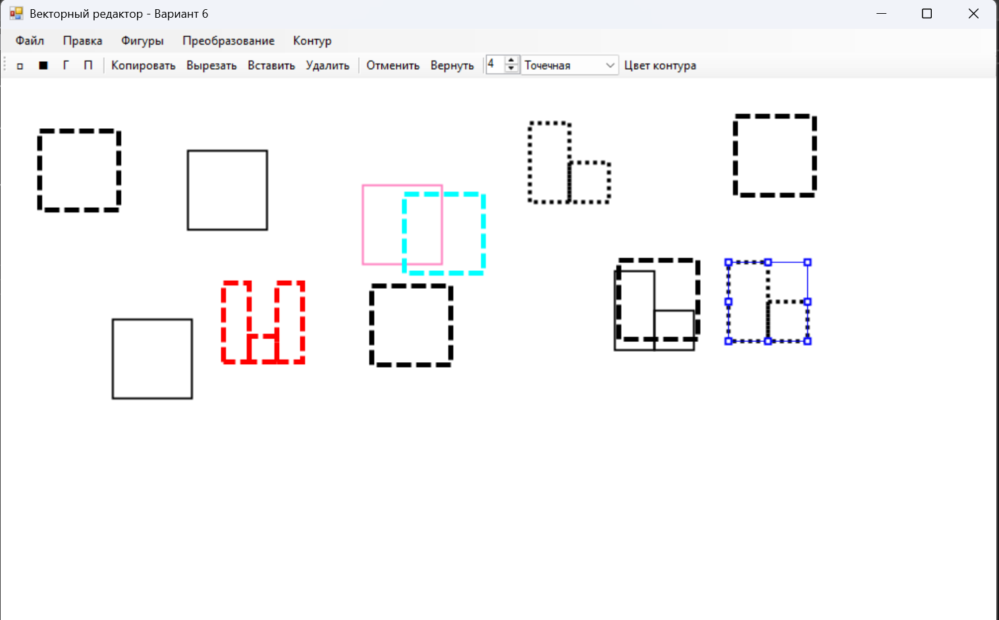

Дополнительные функции

